SYMBIOSIS INSTITUTE OF COMPUTER STUDIES AND RESEARCH CONSTITUENT OF SYMBIOSIS



INTERNATIONAL, PUNE

**NAME**



GHOST CMS

PRAVEER JAIN SAANCHI KUKREJA

**PRN**

20030121081

20030121093

**SEMESTER**-5 **DIV**-B

# Synopsis

Ghost CMS is an open source, user-friendly, modern, fast blogging and content membership website platform. It is based on the modern Node.js technology. Ghost is one of the simplest CMS to set up your own website or blog because to its user-friendly interface, dozens of themes, and sophisticated integrations. Ghost has powerful built-in analytics and SEO features that may be used to enhance your website and user experience. Big names like Nasa, Apple, and Mozilla use Ghost for their blogs.

## How is ghost different from other CMS

1. Exceptionally fast- A headless CMS, it’s built on the stack of modern technologies. Thus, it allows for faster loading time. Even some tests show that Ghost is up to 1900% faster than WordPress. This feature is a great advantage of using Ghost as a website platform.
2. Reliably secure**-** One great security feature of Ghost is that it uses a random string in the URL structure for each page. This makes it difficult for hackers to guess URLs and access sensitive information. And as we know, each page has its own unique URL, so if one page is compromised, the rest of the site remains secure
3. Modern technology- Ghost uses modern technology such as Node.js for backend, backbone.js on the frontend .Some libraries they use are jQuery, jQuery UI, Handlebars, Code mirror etc
4. Great design-New users are welcomed by a collection of pre-filled tales (blog posts) in their dashboard after setting up a new account and creating a publication. Each of these stories (blog posts) describes a distinct step in Ghost's publishing workflow. The stories have two functions: they instruct new users on how to use the platform and they give them practical experience using the

programme. The user onboarding method used by Ghost is a good illustration of learn-by-doing.

Other open platforms are generally old, slow and bloated, while other closed platforms give you absolutely no control or ownership of your content. Ghost provides the best of both worlds,

# Implementation

* 1. Specify requirements, current and future- Current-

To install Ghost locally you will need the following:

* + A computer running MacOS, Windows or Linux
  + A [supported version](https://ghost.org/docs/faq/node-versions/) of [Node.js](https://nodejs.org/)
  + Either [yarn](https://yarnpkg.com/en/docs/install#alternatives-tab) or [npm](https://www.npmjs.com/get-npm) to manage packages
  + A clean, empty directory on your machine
  1. **Basic installation process etc (supported with screen shots etc)**

### First step-

**Install Ghost-CLI-**

Ghost CLI is a command line tool to help you get Ghost installed and configured for use, quickly and easily. The npm module can be installed with NPM or YARN on a local machine, depending on your preference.

### Code line-

npm install ghost-cli@latest -g

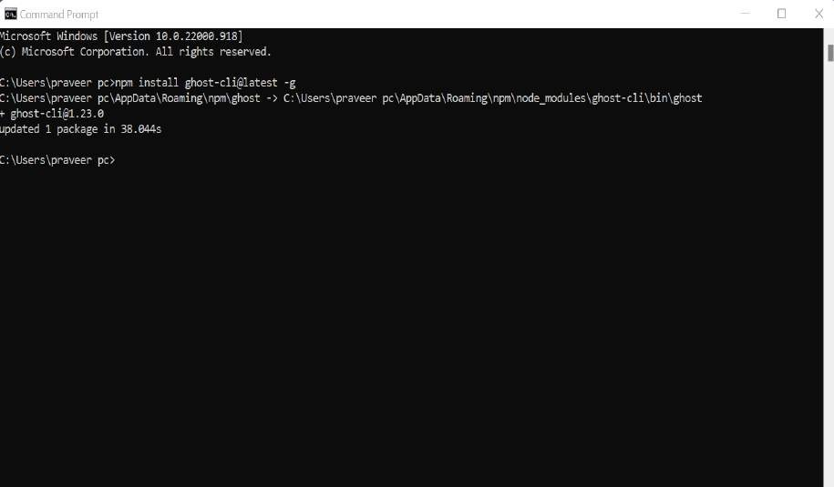

### Second step-

In your terminal, cd into an empty directory and run the install command:

### Code line-

ghost install local

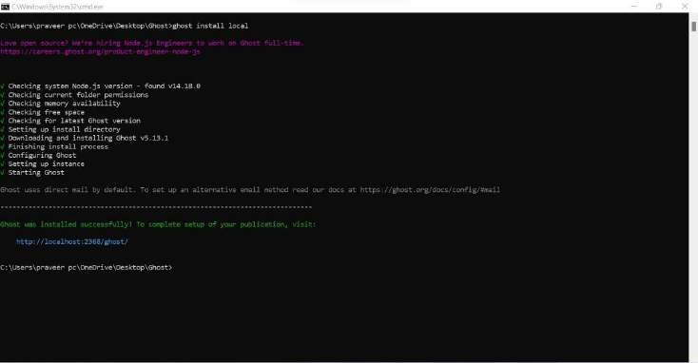

### Third step-

Once the install is finished you’ll be able to access your new site on

http://localhost:2368 and http://localhost:2368/ghost to access Ghost Admin

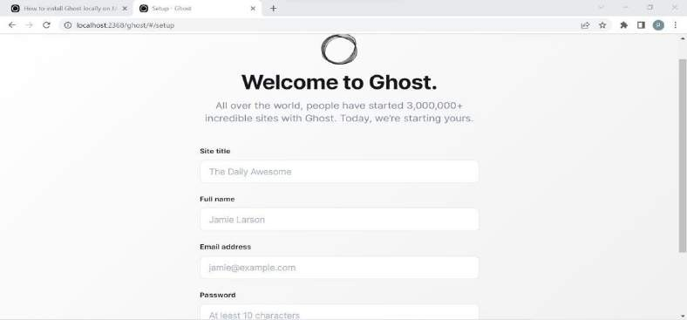

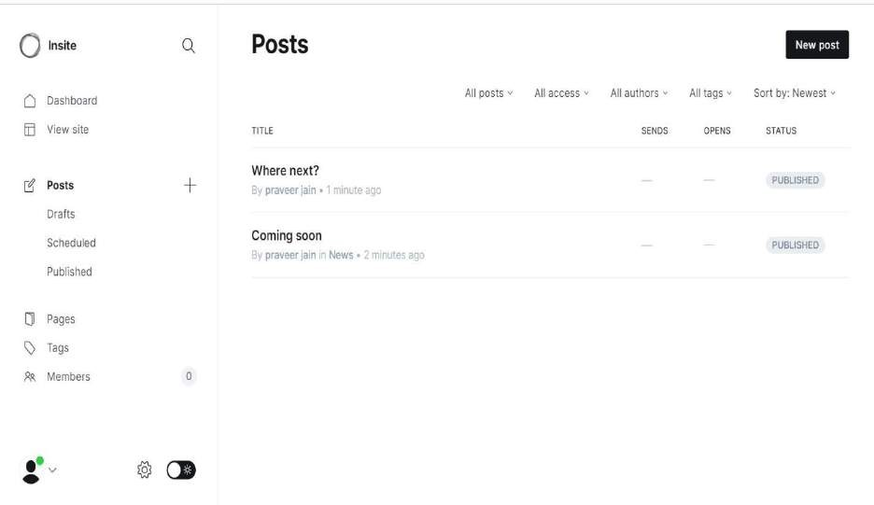

### Some commands-

* + Ghost stop to stop Ghost
  + Ghost start to start Ghost
  + Ghost log views logs
  + Ghost log to list all running Ghost blogs
  + Run Ghost Help for a list of available commands

Usages

* + 1. Demonstration of basic usage of the CMS.

Step1: Dashboard>Settings>Design>Change theme

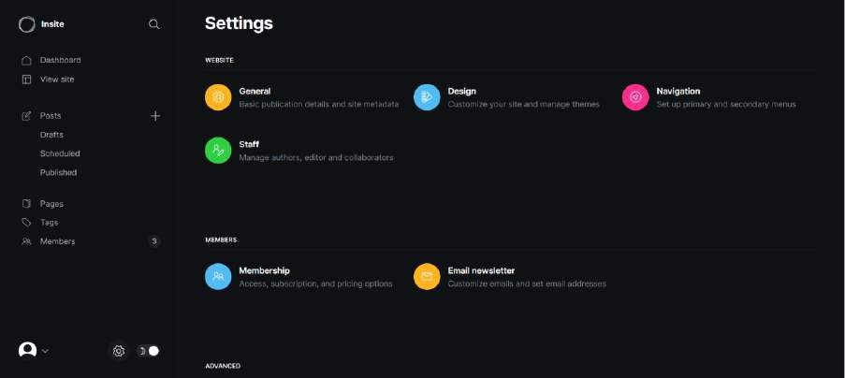

**Step 2:** Once you click on themes, select the theme you want and download

it.If you don’t like the theme you can upload the theme.

I have downloaded a theme that was freely available on ghost

**THEME:** liebling theme

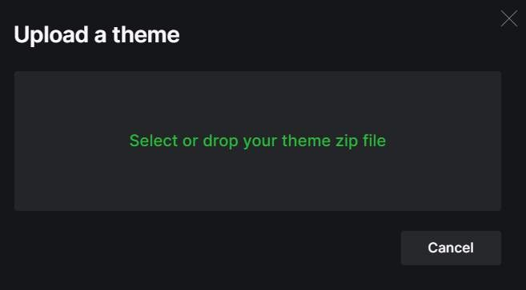

**Step 3:** Now we will go to Settings>General

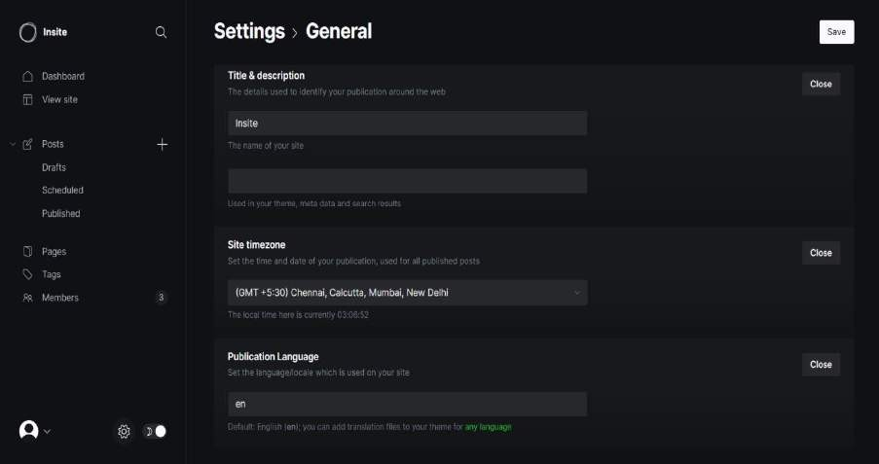

**Part 1**: We will give title and description for our site which will contain multiple pages. We can also set the time zone to engage the audience accordingly. WE can also publish the site in various languages.

Title: India

Time zone: IGMT

Publication language: en(English)

### Settings>Design

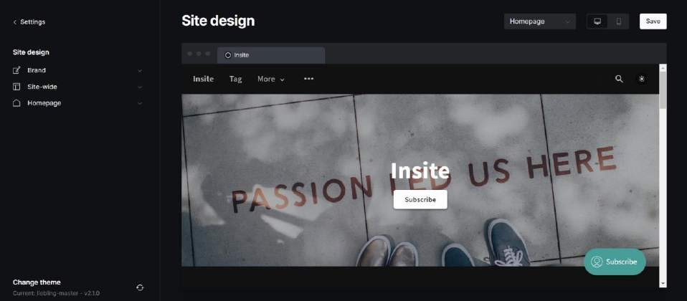

**Part 1: Brand**

1. Site description-Used in your theme, metadata and search results
2. Accent Colour-Primary colour used in your publication theme
3. Upload Icon-The primary logo, should be transparent and at least 600x72px
4. Publication Cover -An optional large background image for your site

### Step 5: Now we will go to Settings>Navigation

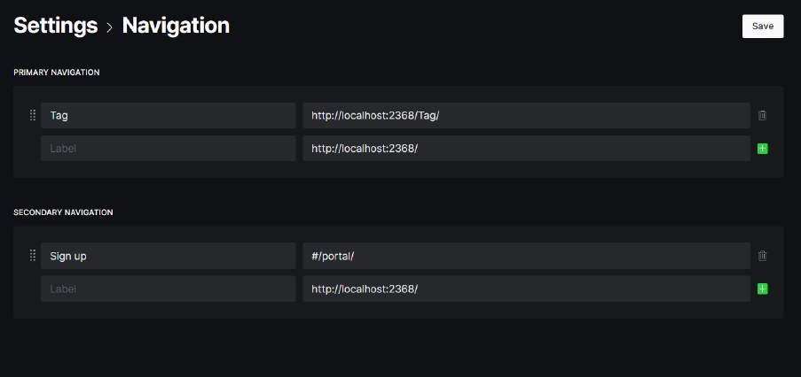

**Step 6**:

Now we will go to Post>Add new post Every post has

1.Add feature image (u can upload it or use unsplash to upload) 2.Add title

3.Add content

We have created multiple such pages

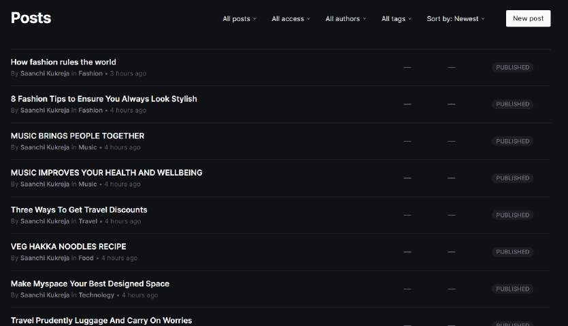

### In every page there is an option of settings

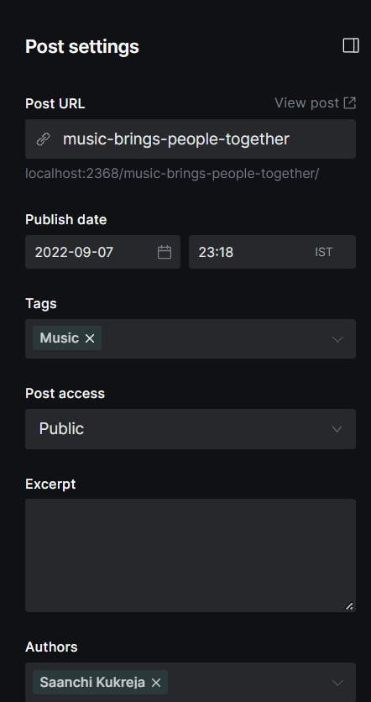

You can set url according to your site's requirements. In Ghost we have an option of publishing the content at the moment or we can also schedule the publish.

If you have content of the same type you can use tags for grouping similar kinds of content together.

### For this go to Tags>Add new tag

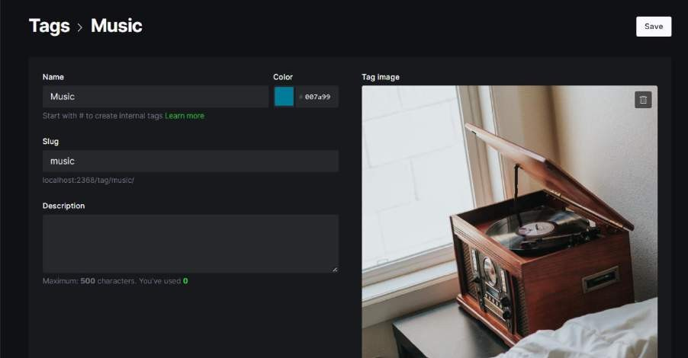

You can choose who will have the access to this particular post and according to the roles that have been assigned editing can be done. Then we publish the content.

**FINAL OUTPUT**

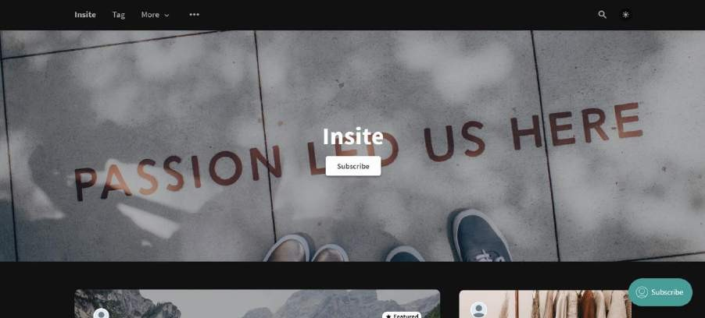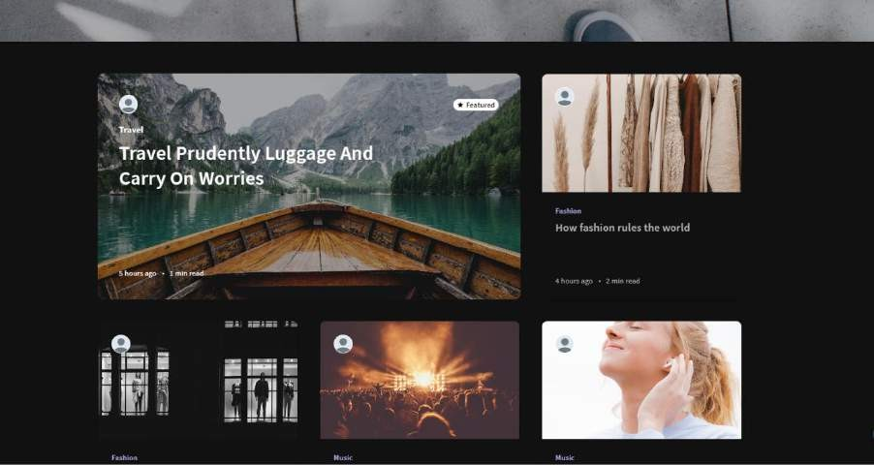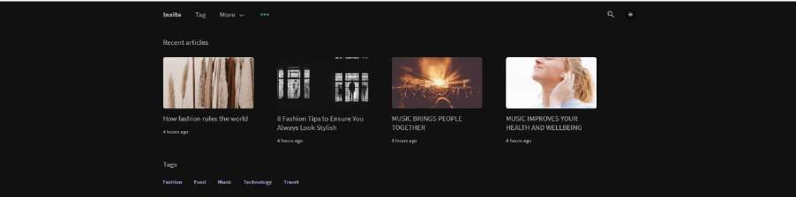

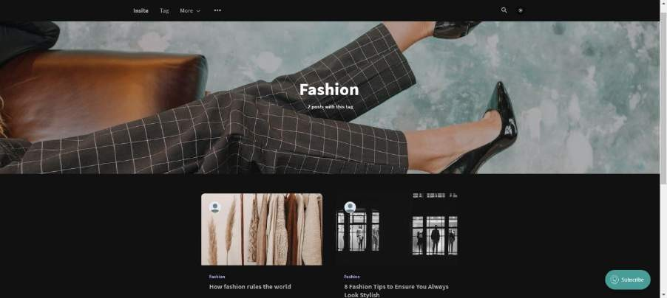

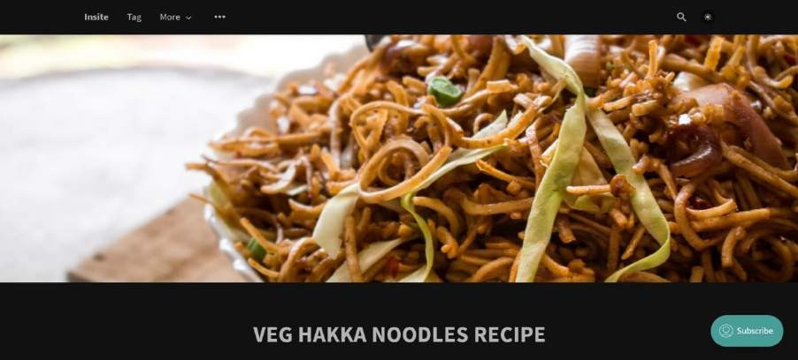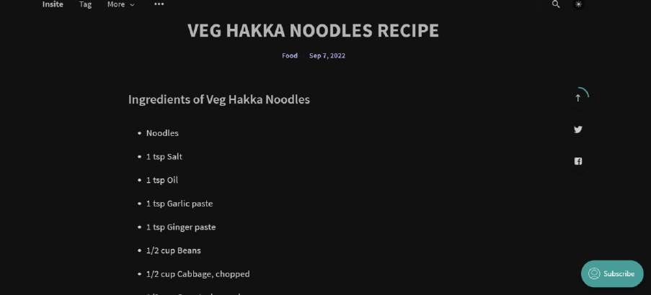

**2. Demonstration of the features of the CMS.**

1. **Pages**

For static content, rather than a feed of posts, pages allow for easy creation of things like Contact and about pages.

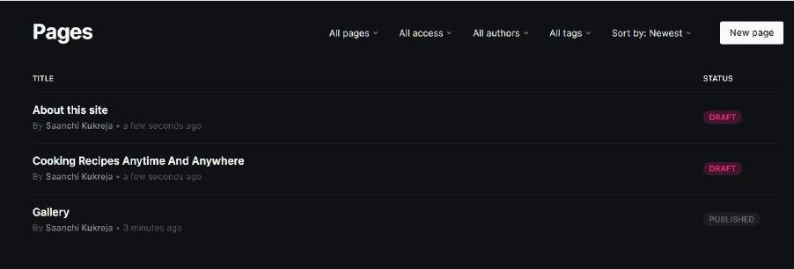

1. **Markdown Support**

The Ghost editor has Markdown in its DNA, with automatic autocompletion of Markdown syntax as you type.

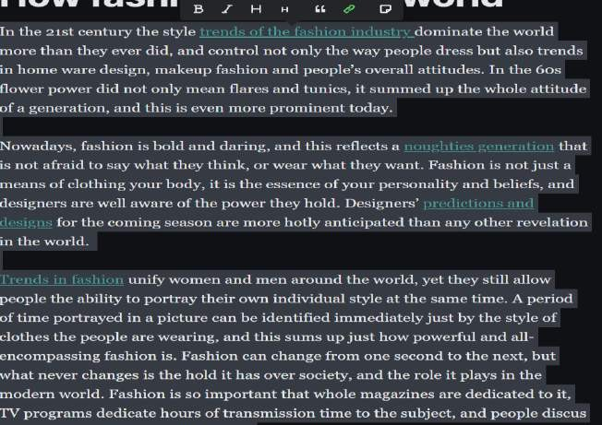

1. **Unsplash Cards**

Explore the largest high-quality royalty-free image library out there from the world's most generous community of photographers.

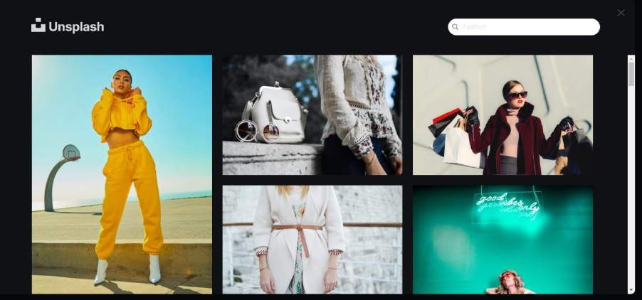

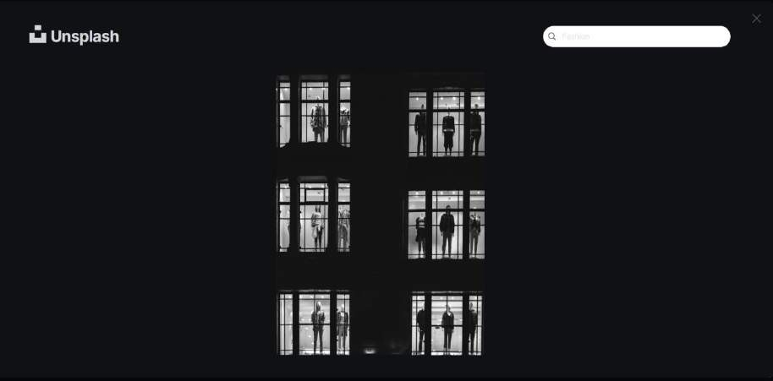

1. **Intelligent Links**

Highlight some text and paste a URL, now you have a link. That's all there is to it! Links can also be added to any image card.

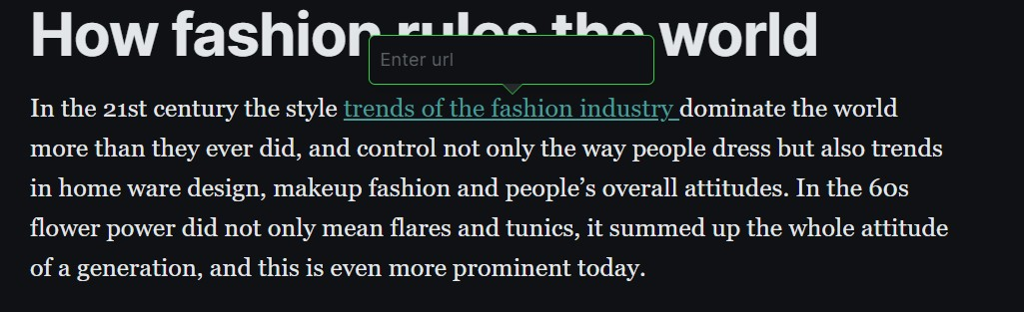

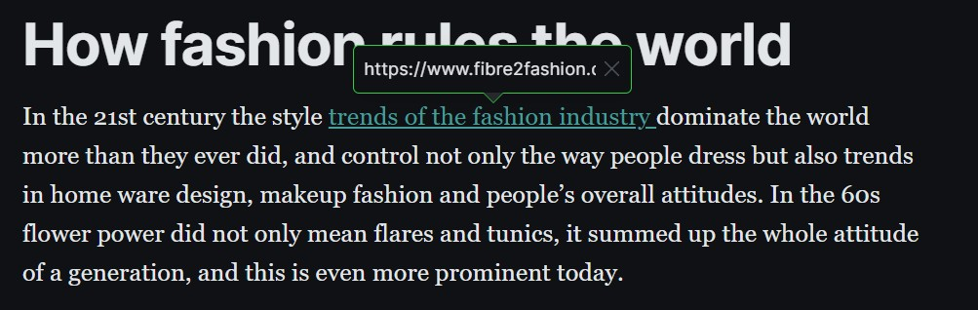

1. **Gallery Cards**

For collections of images, use a gallery card to create a fluid collage of beautiful photography, all with captions.

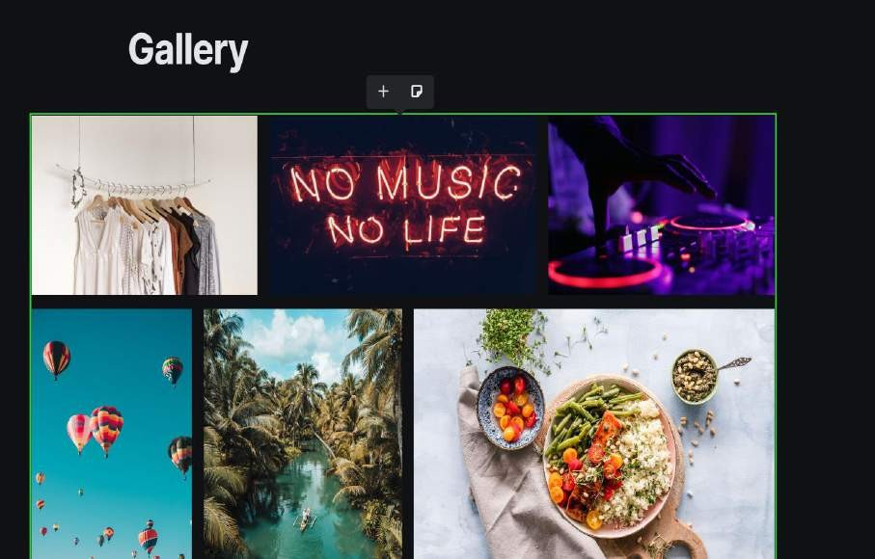

1. **Snippets**

Save any content as a snippet to be reused later, perfect for commonly used logos, images, newsletter templates or a call-to- action.

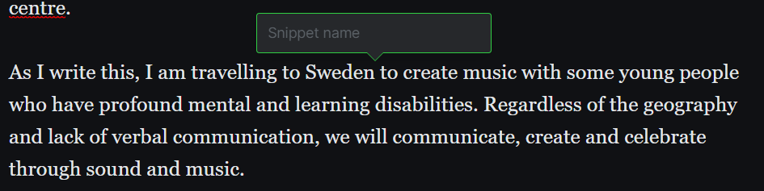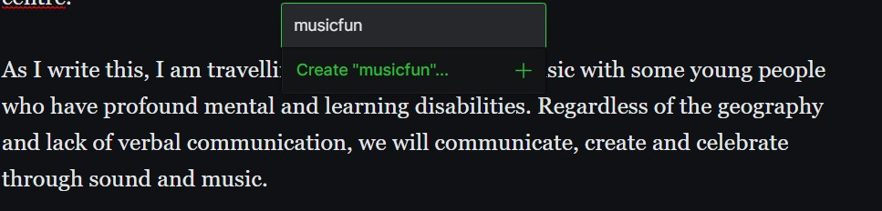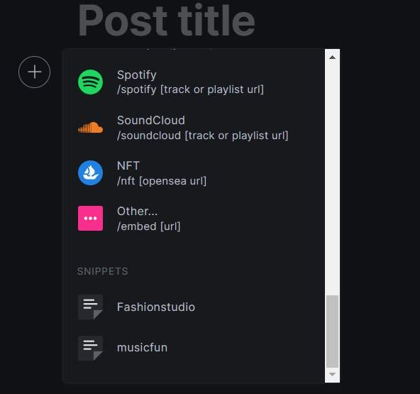

1. **Embed Cards**

Add automatic embed from Twitter, YouTube, SoundCloud, Spotify, Instagram, CodePen, Vimeo, Flickr and many more.

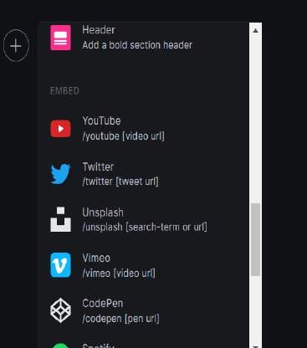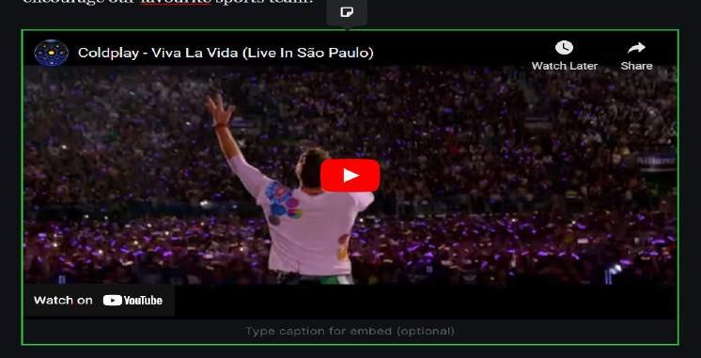

1. **SEO**

Ghost is a platform that offers Full content protection .It protectects content at the server level. This means that your member-only content is never publicly available anywhere, even to search engines.

Full content protection has many benefits. It means there is no way for visitors (or bots) to disable JavaScript or CSS and access your premium content.

### Automatic Google Sitemaps

Ghost will automatically generate and link to a complete Google sitemap including every page on your site, to make sure search engines are able to index every URL.

### Canonical Tags

Ghost automatically generates the correct rel="canonical" tag for each post and page so that search engines always prioritise one true link.

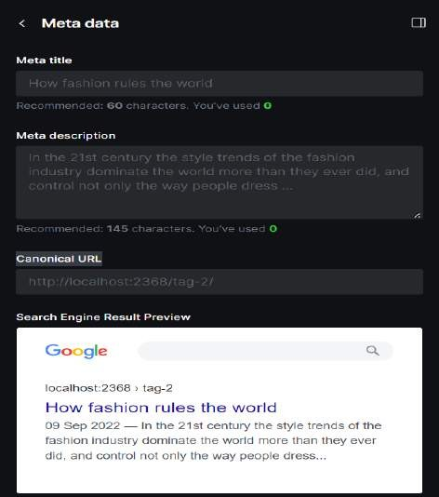

# Custom Profiles

All staff users come with custom profiles including name, bio, location, and social accounts to populate author metadata.

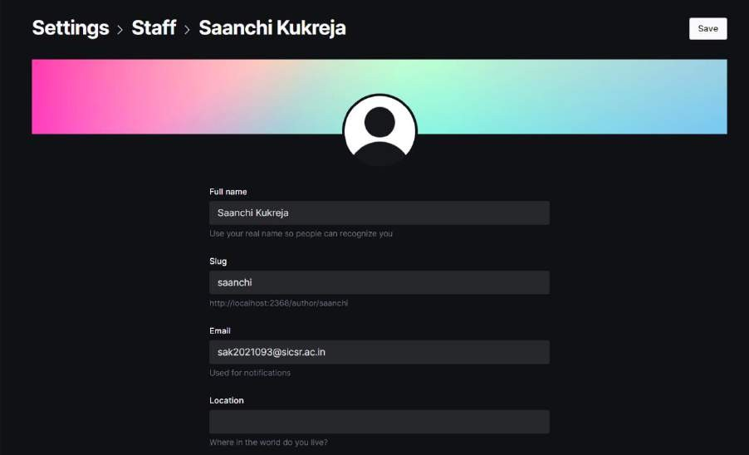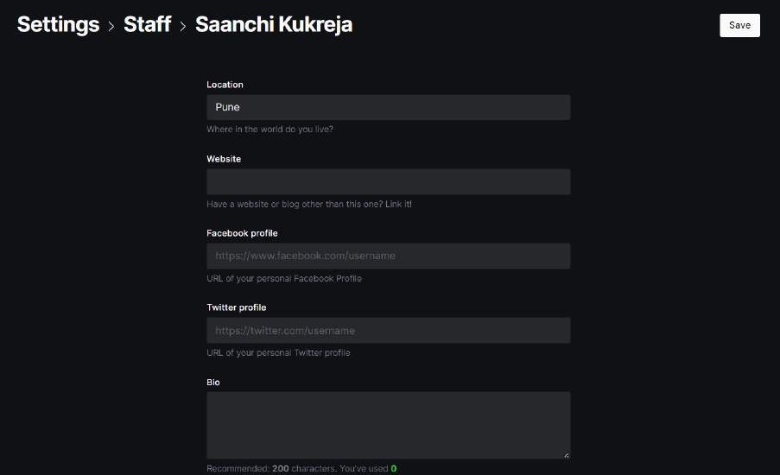

1. **Roles & Permissions**

Staff user access levels include Owner, Administrator, Editor, Author, and contributor; ranging from trusted to untrusted.

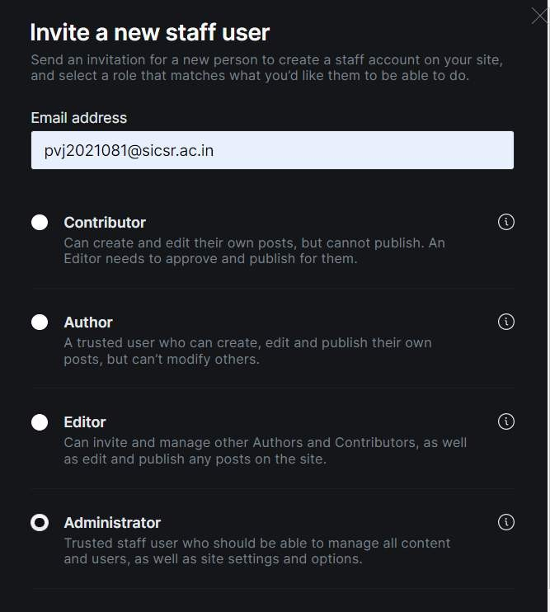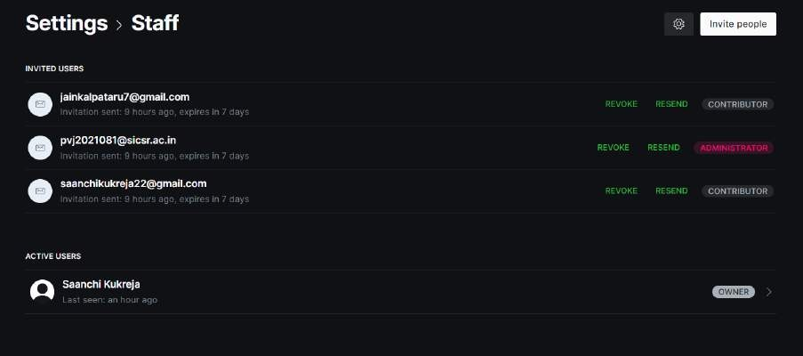

1. **Custom Themes**

Like Ghost itself, themes are open source too. Developing new Handlebars themes for Ghost has a shallow learning curve thanks to extensive theme documentation to get you started.





1. **Powerful CLI**

Ghost-CLI- is a command-line tool for managing Ghost installations which dramatically cuts down the amount of time needed to install, configure and upgrade Ghost for developers.



1. **Integration and Webhooks**

**Integration**-An integration connects an external tool or service to your website in a secure way by sending select information back and forth. This makes it possible to do all sorts of things with your site such as getting copyright free photos to use in the website, creating a platform where all members get updates about recent posts etc.

**Webhooks**-A selection of events which trigger events in Ghost allow for external notifications and automations to be triggered when specific actions take place in Ghost.

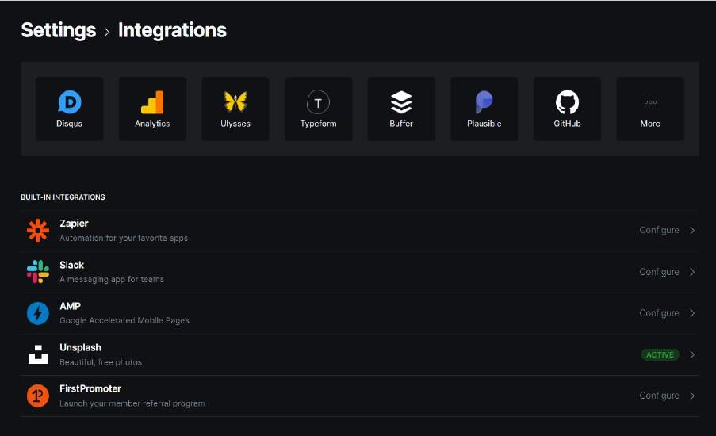

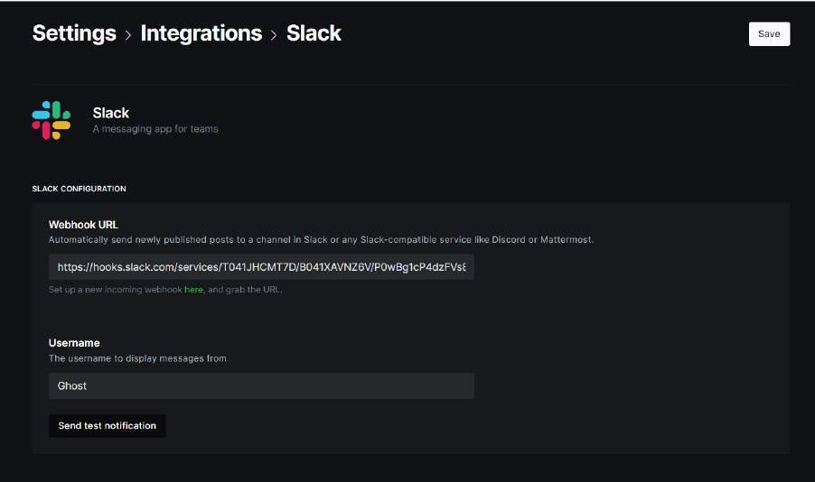

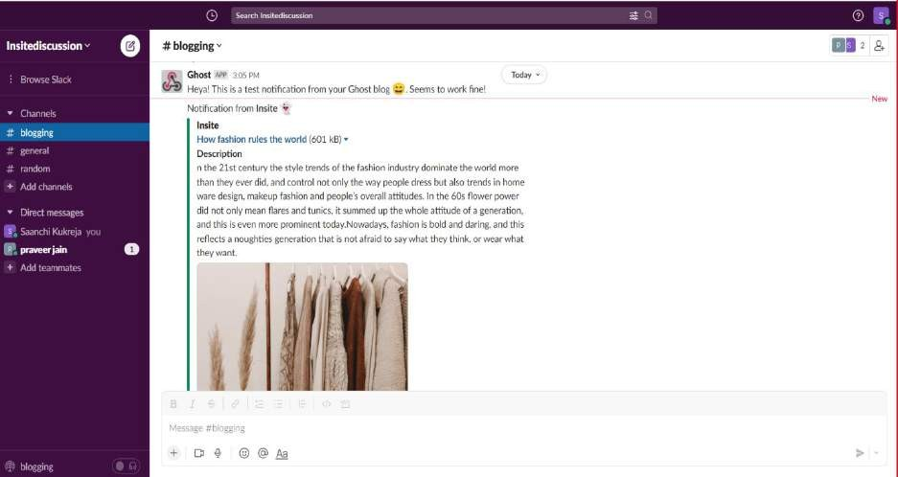

**Findings**

**Problem Identified- In 2 features of Ghost Cms**

1. Ghost has a feature of sending newsletters through mails to the members.

Problem-Unable to send mails to the members even after changing the settings. Even after using other way if the user is trying to sign in ,it is showing an error message ”Failed to log in”

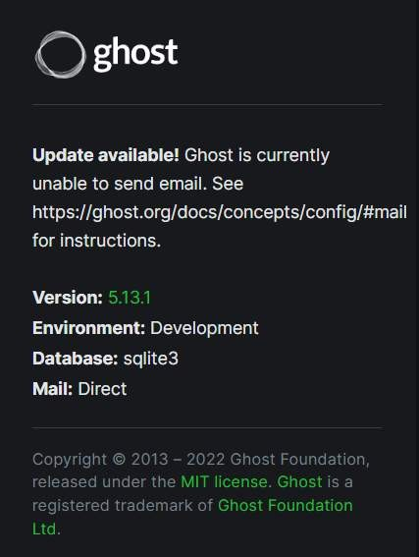

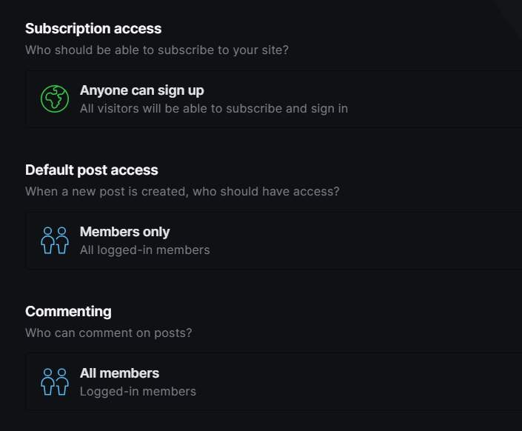

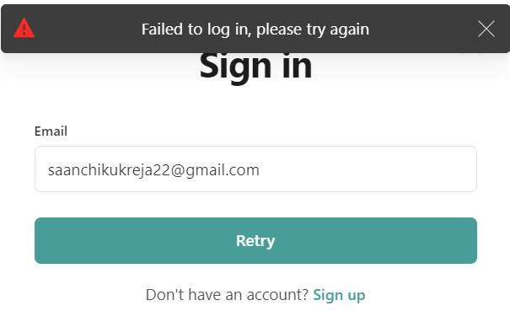

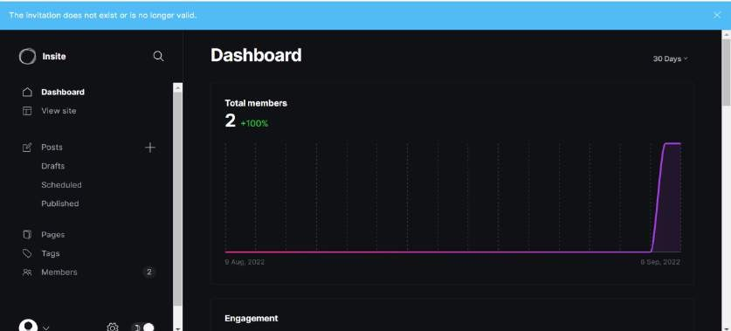

1. For assigning roles in ghost you have to enter the mail of the staff to assign them the role and give them the permissions to work on the site according to the role

Problem-Unable to assign the roles as the mails are not been sent .It is showing an error that unexpected error occurred.

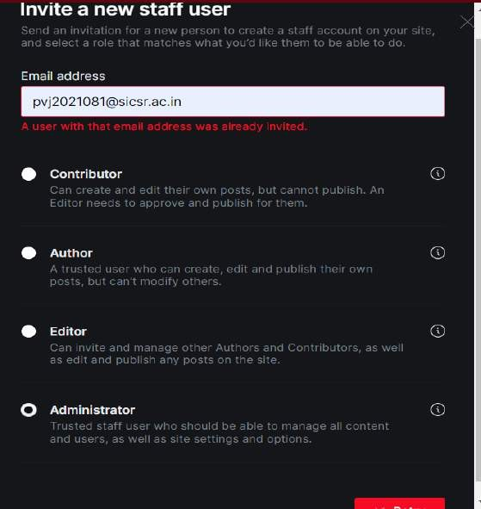

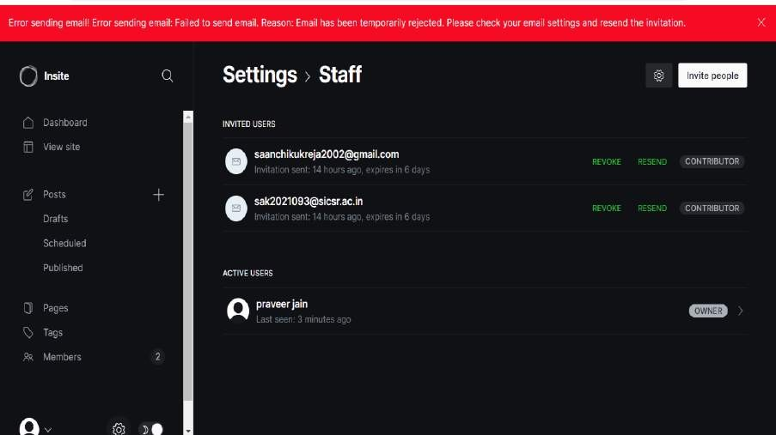

# Discussion

* 1. Identify alternative solutions to these major problems.

Alternative Solution - To use an external platform to send emails.

* 1. Briefly outline each alternative solution and evaluate its advantages and disadvantages.

External Platforms like Mailgun can be used to send emails to the members and staff.

Advantage: It is an email automation service that offers the possibility to send, receive and track emails effortlessly. It lets you measure the business impact of your email campaigns with a/b testing, using tags on your email templates for real-time analytics.

Disadvantage: Mailgun is used by spammers, and sometimes your assigned mail server will get blacklisted because of other users on it. If you end up with a mail server that is blacklisted, your mail will go nowhere.

**Conclusion-**

We observe that the user interface of the cms was aesthetically pleasing and it provide a good amount of features , no plug-in required, Easy to customize and create themes .Simplicity and lightweight is the main concept behind Ghost. The Ghost CMS is still in a long way of development. Feature- rich editor with a focus on the content, huge library of extensions, themes, plug- ins, and integrations.

Here are the major problem we faced few problem like

1. mail error for assigning roles -For assigning roles in ghost you have to enter the mail of the staff to assign them the role and give them the permissions to work on the site according to the role
2. Mail error for membership subscription -Unable to send mails to the members even after changing the settings. Even after using other way if the user is trying to sign in ,it is showing an error message”Failed to log in”

# Recommendations

2. Alternate Solutions (if resultant conclusion tends to be on negative Side

Mail Chimp

The most popular ways to integrate Mailchimp with Ghost are to sync members in Ghost with your email list, embedding custom email subscription or signup forms and creating an RSS driven newsletter.

Can be integrated using zapier .Zapier integration can be used to integrate with ghost cms

Pros; manage your mailing lists, create custom email templates, and nurture and automate your entire marketing campaigns.

Cons: Having a membership-based site can be difficult.

# References

1. Make sure all references are cited correctly.

-<https://ghost.org/feature-index/>

-<https://app.slack.com/client/T041JHCMT7D/C041JLSTGKC>

-<https://ghost.org/resources/community-guidelines-template/>